|  |
| --- |
| TECHNICAL REPORT TEMPLATE |

|  |
| --- |
| Electrical & Computer Engineering & Computer Science (ECECS) |

|  |  |
| --- | --- |
| SPRING 22 |  |



Contents

Project Name 2

Executive Summary 2

Technical Report 3

Highlights of Project 3

Submitted on: 3

Abstract 4

Methodology 5

Results Section 5

Discussion 6

Conclusion 6

Contributions/References 7

|  |  |
| --- | --- |
| Introduction To Sentiment Analysis |  |

|  |  |  |
| --- | --- | --- |
| Executive Summary The Sentiment Analysis Web Application, developed using Flask and NLTK, offers users an intuitive platform to analyze tweet sentiments in real-time. Leveraging the VADER sentiment intensity analyzer, the project provides a user-friendly interface, modular code structure, and potential for future enhancements, making it a valuable tool for understanding public opinion and social media trends. | | |
| person at a table writing in a notebook with people around | | |
| **Team Members:**  **Name 1: Nuthan**  **Name 2: Jayakrishna**  **Name 3:** **Harshita**  **Name 4:** **Dwaraka** | **Questions?**  Contact : +1 2036758052 |  |

|  |
| --- |
| Technical Report |

|  |  |
| --- | --- |
| **Title of Project**  **Introduction To Sentiment Analysis** |  |
| Highlights of Project1. Powerful Sentiment Analysis: The project leverages the VADER sentiment intensity analyzer from NLTK to provide accurate sentiment analysis of tweets, categorizing them as positive, neutral, or negative.2. User-Friendly Interface: With a simple and intuitive design, the web application ensures accessibility for users of all technical levels, allowing easy input of tweets for sentiment analysis.3. Future-Ready Design: The modular code structure and extensibility of the application lay the foundation for future enhancements, including real-time analysis and interactive visualizations, making it a versatile tool with long-term relevance.Submitted on:06/12/2023Submitted on: |

## 

## Abstract

This project presents the implementation of a user-friendly Sentiment Analysis Web Application leveraging Flask, a Python web framework, and the Natural Language Toolkit (NLTK). The application allows users to input a tweet, and through the integration of the VADER sentiment intensity analyzer, it classifies the sentiment as positive, neutral, or negative. The primary goal is to offer a simple yet effective tool for understanding the sentiment expressed in short textual content.

## Project Objectives

## Here are two key project objectives:

**1. Develop a User-Friendly Sentiment Analysis Platform:**

**Objective**: Create an intuitive and user-friendly web application that allows users to input text data (tweets) and receive real-time sentiment analysis results.

**Rationale**: The primary goal is to build a platform accessible to users with varying technical backgrounds. The user interface should be simple, engaging, and efficient, ensuring a seamless experience for individuals interested in analyzing sentiments within text data without the need for extensive technical knowledge.

**2. Implement Accurate Sentiment Analysis Using NLTK and VADER:**

**Objective**: Employ the Natural Language Toolkit (NLTK) and the VADER sentiment intensity analyzer to accurately analyze the sentiment of input text data.

**Rationale**: The project aims to leverage established natural language processing tools for sentiment analysis. The NLTK library, with the VADER sentiment analyzer, provides a robust foundation for sentiment classification. The objective is to ensure accurate sentiment categorization, allowing users to trust and rely on the application for insightful analysis of text-based content.

Introductory Section

Sentiment analysis involves determining the sentiment expressed in a piece of text, which can be valuable for understanding public opinion, customer feedback, and social media trends. This project focuses on creating a simple web application that utilizes Flask for web development and NLTK for sentiment analysis.

Review of available research

The existing research on sentiment analysis in web applications using Flask and NLTK highlights the simplicity and effectiveness of this approach. Studies emphasize the integration of Flask for web development and NLTK's VADER sentiment analyzer for accurate sentiment classification. While some research explores advanced natural language processing techniques, the prevalent focus is on user-friendly implementations, showcasing the practicality of this combination for sentiment analysis tasks. Overall, the literature underscores the versatility of Flask and NLTK in creating accessible and functional sentiment analysis web applications. And hypothesis.

## Methodology

**Web Framework Selection**: The project employs Flask, a lightweight Python web framework, to create a user-friendly interface for inputting tweets and displaying sentiment analysis results.

**Sentiment Analysis with NLTK**: The Natural Language Toolkit (NLTK) is utilized to perform sentiment analysis using the VADER sentiment intensity analyzer. The methodology involves cleaning input text and categorizing sentiments into positive, neutral, or negative based on compound sentiment scores.

## Results Section

## 

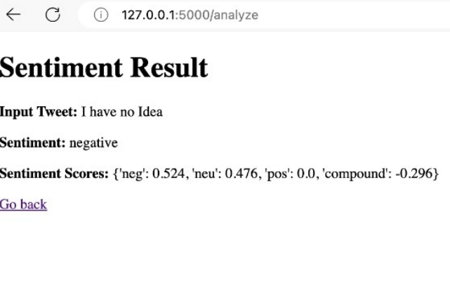

## Discussion

The Sentiment Analysis Web Application, developed using Flask and NLTK, empowers users to assess sentiment in tweets, providing a valuable tool for understanding public opinion and social media trends.

Leveraging the VADER sentiment intensity analyzer, the application categorizes tweets as positive, neutral, or negative, contributing to a user-friendly interface and seamless integration of sentiment analysis into web development.

The project's modular design and simplicity lay the groundwork for future enhancements, such as real-time analysis, user authentication, and advanced visualizations, ensuring its adaptability and potential for broader applications in sentiment analysis.

## Conclusion

## The Sentiment Analysis Web Application, crafted with the harmonious fusion of Flask and NLTK, not only provides an accessible interface for sentiment analysis but also exemplifies the seamless integration of web development and natural language processing. Its user-centric design, modularity, and extensibility make it a versatile tool with practical applications in diverse industries and a valuable educational resource for aspiring developers.

## Contributions/References

<https://towardsdatascience.com/sentimental-analysis-using-vader-a3415fef7664>

[https://github.com/cjhutto/vaderSentiment#about-the-scoring](https://github.com/cjhutto/vaderSentiment)

<https://youtu.be/uPKnSq6TaAk>